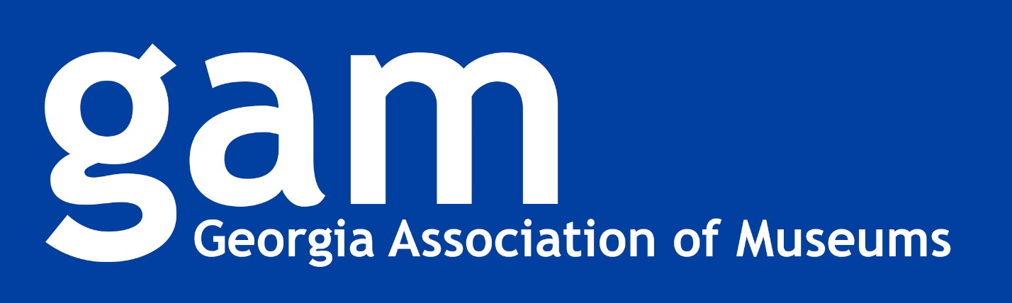

2022 Awards Luncheon
February 9, 2022

The GAM Awards program recognizes outstanding achievements of people and organizations that make up the museum community across Georgia. The opportunity for GAM member-institutions to highlight the good work of their employees, volunteers, and supporters also draws attention to the important role that museums, galleries, and other cultural institutions play in our communities. Additionally, the awards program allows GAM to achieve its goals to:

- Encourage growth and improve professional practices of museums and non-profit galleries throughout the state;
- Stimulate public interest, support, and understanding of museums and non-profit galleries of all disciplines;
- Increase general understanding of the roles of museums and non-profit galleries as community resources for improving the quality of life and continued learning for all citizens of the state;
- Maintain and develop relations among institutions and staffs for the interchange of information and development of cooperative efforts to achieve these objectives;
- Maintain relations with various governmental agencies; and
- Promote research to foster understanding of cultural and natural resources of the community and state.

Patron
Recognizes an individual or group who has worked closely with a museum (or museums) demonstrating leadership and providing assistance. This person/group is a major promoter of the museum(s) in his/her/their local area or statewide and in the past year has made a significant contribution and will continue to be a supporter in the future.

Winner: May B. and Howell Hollis
Nominated by: Historic Oakland Foundation

Student Project
Recognizes contributions of student work to the field of museums and galleries. An individual or student group is eligible for this award. Projects show professional guidance of student effort, but clearly demonstrate meaningful work by students in the design, implementation, and promotion of the nominated project. Projects might include, but are not limited to, an education or outreach program, a digital history project, an oral history project, or an exhibition.

Winner: Preservation of Historic Weapons
Lucas Hardy
Nominated by: Newnan Coweta Historical Society

Education
Recognizes an on-site or outreach program that has as its primary purpose the education of student and/or adult audiences. This program extends the organization’s mission and demonstrates scholarship and originality contributing to the cultural and education fabric of the organization’s community and the state and is an example of excellence in theory, planning, and implementation. An educational component of a larger exhibition or special project can be nominated for this award if the intention is to focus solely on the educational aspects of the larger project.

Winner: Albany Convention & Visitors Bureau, Chehaw Park & Zoo, Flint RiverQuarium, and Thronateeska
For the program: Southwest Georgia Learning Initiative

Honorable Mention: Marietta Museum of History
For the program: Tombstone Cleaning Workshop

Multimedia
Recognizes projects that are intended to be primarily experienced using visual or audio media. Examples include podcasts, interactive kiosks, social media campaigns, videos, and virtual interactions (webinars, virtual field trips, etc.). Multimedia projects have extended the organization’s audience and demonstrate creative solutions without sacrificing good scholarship and professional best practices.

Winner: Booth Western Art Museum
For the project: American Indians: Cultures and Contributions Virtual Field Trip

Honorable Mention: Georgia Southern University Museum/Dr. Michael Van Wagenen
For the project: Saints and Sinners: Salvation and Damnation in Latin American Folk Art

Museum Exhibition
Recognizes an art, historical, or science exhibition of note that demonstrates scholarship and originality contributing to the cultural fabric of the state. The exhibition is an example of excellence in theory, planning, and implementation and has effectively reached and broadened the museum or gallery audience. Exhibitions that include multimedia elements but are primarily designed to be experienced as a traditional exhibit should be included in this category.

Winner (Category #1, <$1,000): Newnan Coweta Historical Society
For the exhibition: A Newnan Girl Away at School

Winner (Category #2, $1,000 - $25,000): Pebble Hill Plantation
For the exhibition: Green Arrow Tour at Pebble Hill Plantation

Honorable Mention (Category #2): Chipley Historical Center
For the exhibition: The 2021 Chipley Historical Center

Winner (Category #4, >$100,000): Georgia Museum of Art
For the exhibition: Emma Amos: Color Odyssey

Special Project
Recognizes a project or program of note, often with multiple component parts, that does not more closely fit the criteria for other categories such as exhibition, education, or multimedia. This category can also be used for multi-part projects when all aspects of the project should be evaluated as a whole. These projects demonstrate scholarship and originality contributing to the cultural fabric of the state and provide examples of excellence in planning and implementation while expanding the museum or gallery audience.

Winner (Category #1, < $1,000): The Georgia Museum of Agriculture Gallery
For the project: The Discovery, Research, and Identification of a Rare Artifact and its Journey from New York to Georgia, and the Connections Discovered Along the Way

Winner (Category #2, $1,000-$25,000): The Georgia Museum of Agriculture Gallery
For the project: Beauty Amidst Trials: Capturing a Pandemic Year Through Two Exhibits at the GMA Gallery

Honorable Mention (Category #2): Thomasville History Center & Ethos Preservation
For the project: Lapham Patterson House Future Project

Advocacy
Recognizes an individual or group that has successfully advocated at the state and/or federal level representing Georgia’s museum community to provide heightened interest and voice, in a significant and meaningful way, while working to incorporate museum interests into state and federal policy.

Winner: JoAnn Wood
Nominated by: Museum of History & Holocaust Education and the Booth Western Art Museum

_______________________________________________________

Museum Volunteer
Recognizes an individual who does not receive payment or specific educational credit from an organization but has contributed significant time and effort in developing that organization’s programs and exhibitions in an outstanding way. This person has enlisted the aid of other volunteers in supporting Georgia museums and galleries and has served as an advocate of Georgia museums and galleries.

Winner: Jay Gorday
Nominated by: Tellus Science Museum

Museum Professional
Recognizes an active museum or gallery employee working in the state of Georgia. This individual is involved professionally on the local, state, and national level and has demonstrated leadership in the profession; has worked to promote the goals of GAM; and has been a member of GAM for at least one year.

Winner: Shawnya L. Harris
Nominated by: Georgia Museum of Art

Emerging Museum Professional
Recognizes the contributions of an individual who has been working full or part time in the field for less than 10 years. Considerations include how the recipient has contributed to their organization and may include recommendations from multiple museums, recognizing that the career path for EMPs has many different routes and experiences.

Winner: Allison Moore
Nominated by: Heritage Sandy Springs

Winner: Keith Smith
Nominated by: The Columbus Museum

Institution
Recognizes GAM institutional members (nonprofit museums, historic sites, and galleries) for leadership at the local and statewide level. This organization has been a leading institution in Georgia with a past record of accomplishment and acts as an important cultural resource in its community; has taken an active role in promoting communication and cooperation among Georgia museums and galleries; and has provided an on-site or outreach program that extended the museum’s mission while educating student and adult audiences.

Winner: The Georgia Writers Museum
Nominated by: Georgia Writers Museum Board of Directors
____________________________________________________________

Lifetime Achievement
An individual in any category who has consistently and selflessly worked over multiple decades to improve the state of museums and galleries in their community and/or across the state during their lifetime; this person’s collective accomplishments exemplify commitment, dedication and excellence; and has had a far-reaching impact in their field.

Winner: Dr. Gordon Jones
Nominated by: Atlanta History Center

